CURRICULAM VITAE
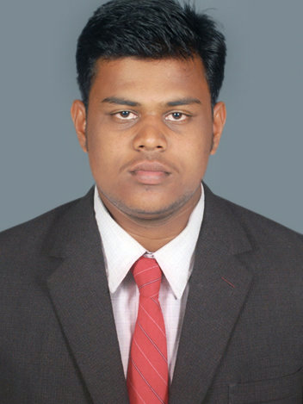  ANAND.B  Personal Data:  Date of Birth : 17/06/1989  Gender : Male  Father’s Name : Bagavathiappan.S  Nationality : Indian  Marital Status : Single  Passport : K5351143  Permanent Address:  9/76, west street,  Marungoor,  Kanyakumari District-629402,  TamilNadu,  India.  Contact:  Mobile:  (+91)9952246362  (+91)9488948362  Mail:  nanjilanand@gmail.com  nanjilanand@yahoo.com | Career Objective  To obtain a challenging and professional position in an esteemed organization so as to apply my analytical and technical knowledge for the betterment of organization as well as myself.  Educational Profile  - B.E (Computer Science & Engineering ) 2006 - 2010  Jayamatha Engineering college, Aralvaimozhi.  Aggregate 60.2%  - Intermediate Public Examination (+2) 2005 - 2006  Govt Higher Secondary School, Kumarapuram Thoppur.  Aggregate 74.9%  - Secondary School Certificate (10th) 2003 - 2004  Govt High School, Eraviputhoor.  Aggregate : 81.6%  Computer Proficiency  Languages : Java, C, C++.  Web Design : HTML, Photoshop  Packages : MS Office.  Certified Course  - Honors Diploma in Computer Hardware and Networking.

Working Experience

Previous work
- Duration : From Jul 2010 to Dec 2010
- Position : Hardware&Networking Engg
- Company : Delta Computers
Present Working
- Duration : From Feb 2011 to Till now
- Position : Data Entry Operator
- Company : Indus Projects Ltd, Mumbai
- Project : Creation Of Surface Facilities at Cauvery Asset ONGC GCS RAMNAD

Project Profile

Topic: Bayesian Image Recovery for Dendritic Structure under Low Signal to Noise Conditions” Image Processing.
Language: Java.
Back-end: Microsoft Office Access.

Personal Strength

Skills:
- Good Analytical and optimist approach to problem.
- Good Communication Skills.
- Well organized and easily meets deadlines.
- Ability to deal with people diplomatically.

Declaration

I hereby assure that the details furnished above are accurate and true to the best of my knowledge.

Place: Marungoor, yours faithfully,

Date:
[ANAND.B]

